Description | Muahahhahahahha! I changed my Netflix password.  To use my account, you have to use your years of language classes.  My Netflix account uses a long, number-only password. I’ll give you a chance to watch One Piece Live Action Season 2. If you take too long, I’ll spoil it.  (Flag example:RCCTF{seattle})
Files | ToMyBuddy.m4a
Hint(s) | The first language is a South Indian palindrome. Second has the most native speakers in the world. Third is the official language of Lamine Yamal’s birthplace. And fourth …  First language words are 2- and 3-digit numbers. The rest are 2 digits.

Walkthrough | While not perfect, after playing the audio from my phone, this website was able to detect most of the numbers.  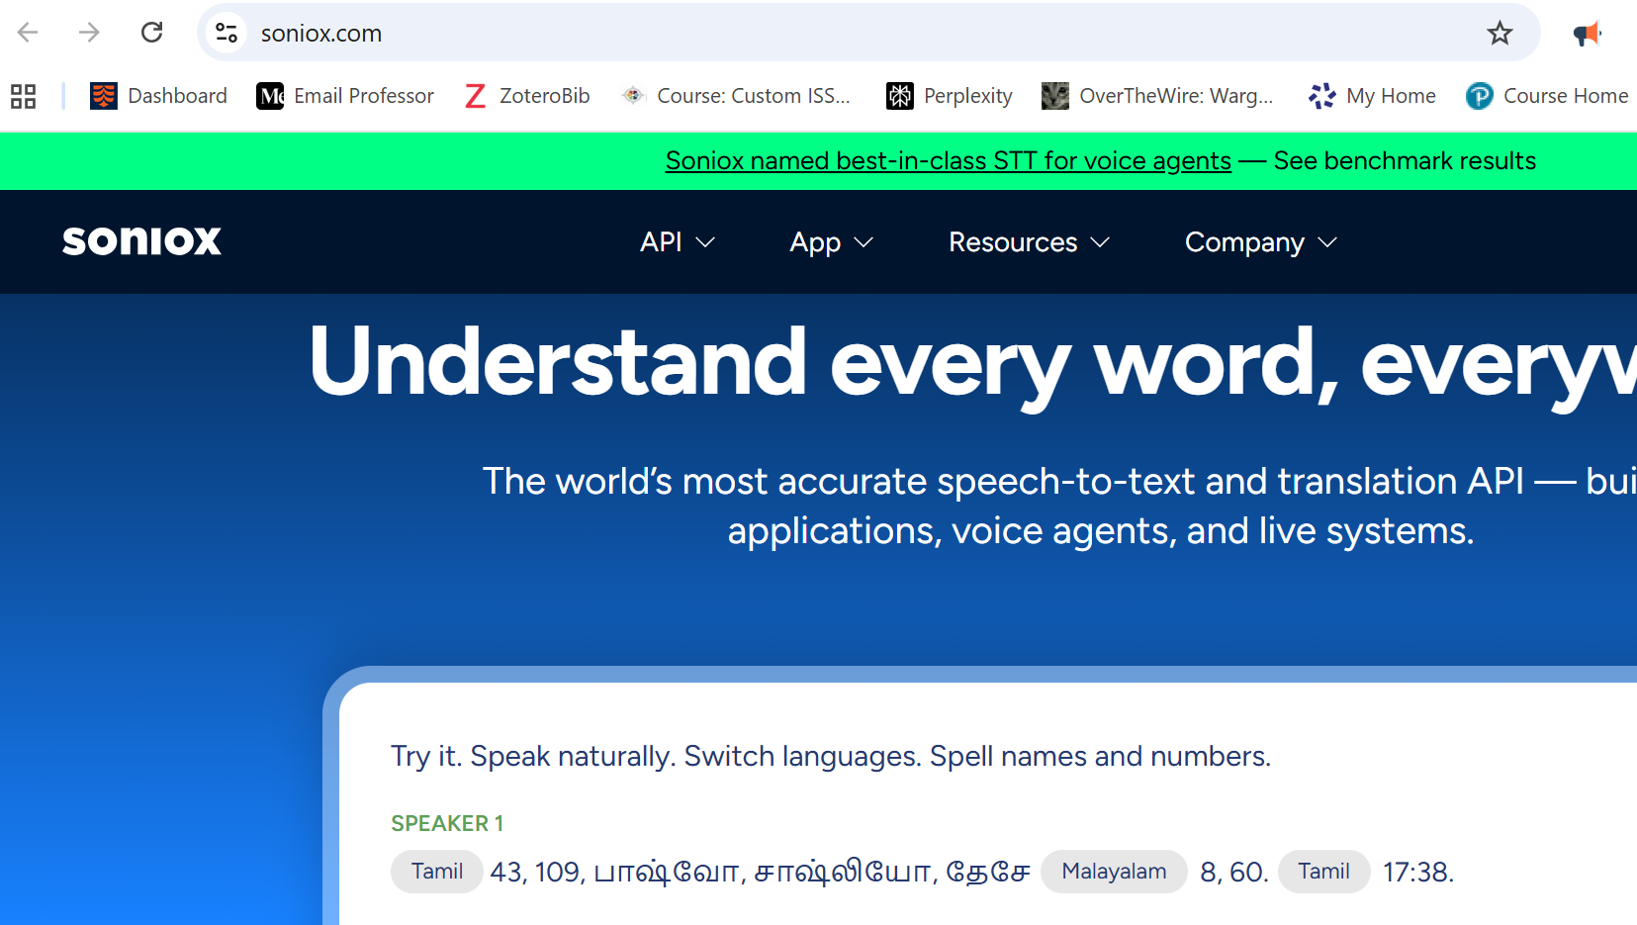  With the first language out of the way (43109), finding the second language can be done with the hint or by being able to recognize Chinese (the tools I used couldn’t detect it), then use a website like omniglot to find what numbers it could be.  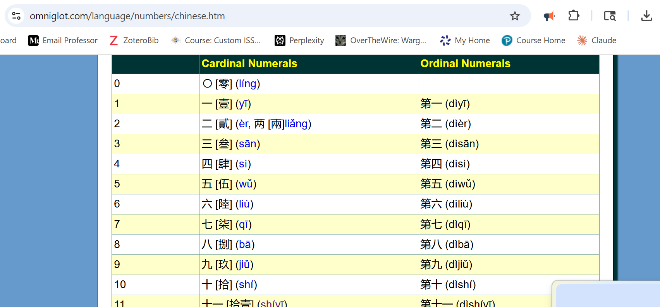  This website can transcribe the audio. Search the words, and you get 18 & 60.  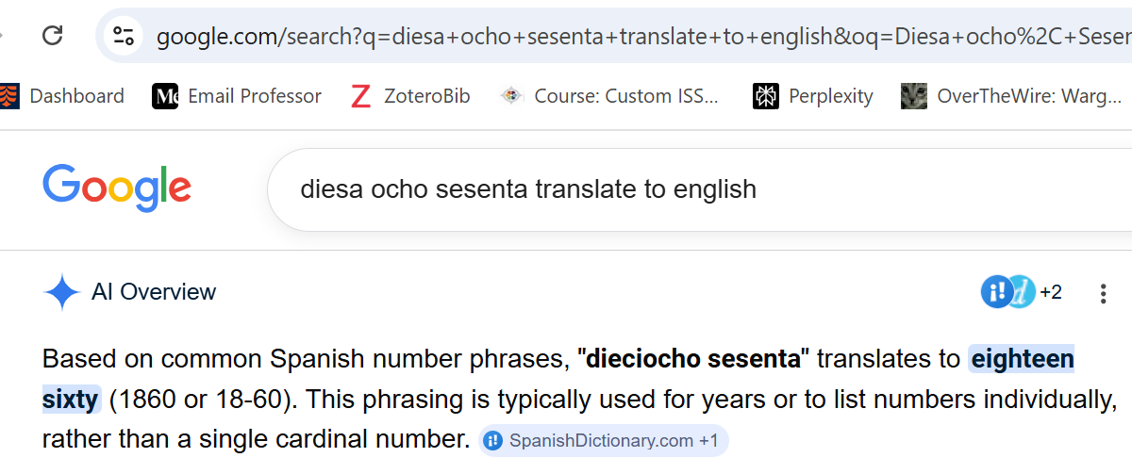  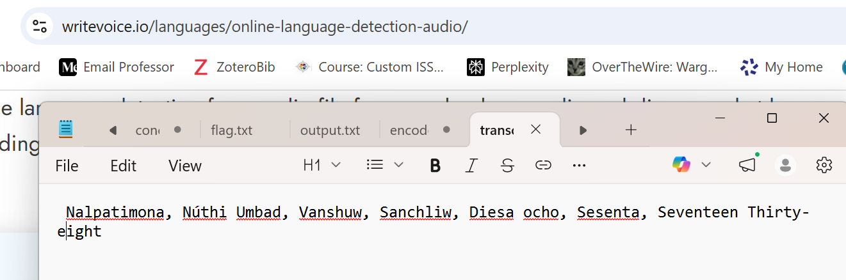  The fourth language is English. Put all of the numbers together to get the flag.
Flag | RCCTF{43109853618601738}

